(Approx. 546 words)

Internet of Things Data Tracking
By Jeff Wilkinson, Present, Sun City Summerlin Computer Club, NV
June 2019 issue, Gigabyte Gazette
www.scs-cc.com
pres.scscc (at) gmail.com

As I continue to delve into the ramifications of targeted marketing and how it might affect us in our everyday lives, I’m diverted to the Internet of Things (IoT). A little research on IoT and how data from seemingly innocuous devices could be collected and used, proved enlightening, with a tremendous amount being written on this subject.
How will this data flow through the various collection systems? Will data be captured in real time or transmitted in anonymous batches? How will it be used, and who will have access to the purportedly anonymous data sources? Devices supplying data could include fitness wearables, various accessories in cars, IoT equipped appliances, such as refrigerators, washers, dryers, health trackers, Smart TV’s, security cameras and devices, web connected eyeglasses, and the list goes on.

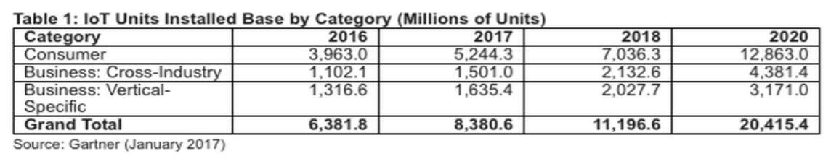
IoT devices will outnumber the world's population this year for the first time.
A recent study indicated that over half of those surveyed would be willing to receive some ads.

This, of course, indicates that some form of data tracking is needed, not only of our computers and phones, but of the fitness monitors used to track our physical activity, the refrigerators monitoring our supply of milk, or the processor in our new car monitoring our driving!

Much of the data can be used for non-nefarious purposes, such as product improvement and future product development. But will some of this data be used to extrapolate future drug health care needs, based on current fitness monitor feedback data? Will this data find its way into insurance actuarial tables? And, of course this data will be used for more fine grain targeted marketing. The management of this data has, in fact, spawned new companies who will monetize this valuable data. It will be another learning experience, as hopefully the public is able to decide what is acceptable and what is not.

On the plus side, IoT can help create Smart Homes and improve machine efficiency, such as heating and cooling devices. IoT can be used in wearables for security and identification, health monitoring and reporting, smart retail and inventory control, optimization of farming, and supply chain activities, to name a few.

Many positive things come out of the use of IoT data, such as Rolls Royce using this data, along with artificial intelligence (AI), to create business benefits to customers and improve their products. They have created “Data Innovation Cells” which use collected data to test new ideas to improve performance, maintenance cycles, and safety, and develop product improvements. It is certain that data from IoT connected devices will unlock efficiencies, spawn innovation, and lead to meaningful insights of all kinds!

So, the IoT is actually being used in numerous positive ways, and engineers are just beginning to see all the potential benefits. Of course, putting sensors and retrieving feedback from every process can result in an overabundance of data, which may or may not prove useful. While all of this can be viewed as an overwhelming invasion of privacy, it can also be looked at as an exciting step forward and a world full of new opportunities, with positive outcomes around every corner!

